**TravelApplication Implementation Document:**

**1.Welcome page Design:**

Note:

We will only try to construct the inout and output fileds using Angular js. Css will be done after wards.

Example look:

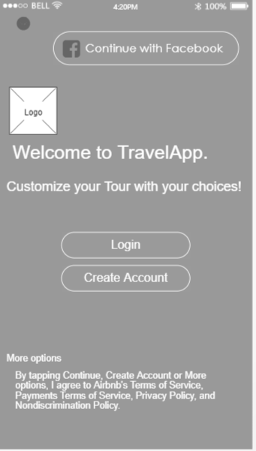

Elements:

1. Text
2. Buttons:

1.Login button

2.Continue with facebook login button

3.Create account button